Servo Motor : types and working principle explained.

[November 6, 2018](https://engineering.eckovation.com/servo-motor-types-working-principle-explained/)[Akshat Goel](https://engineering.eckovation.com/author/akshatgoel/)

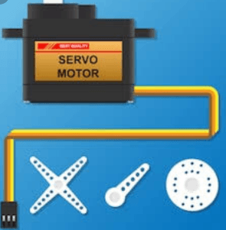

**All you need to know about servomotors –**

**Abstract :**

The servo motor is most commonly used for high technology devices in the industrial applications like automation technology. It is a self contained electrical device, that rotates parts of machine with high efficiency and great precision. Moreover the output shaft of this motor can be moved to a particular angle. Servo motors are mainly used in home electronics, toys, cars, airplanes and many more devices.

Thus this blog discusses the definition, types, mechanism, principle, working, controlling, and lastly the applications of a servo machine.

**Definition :**

A servo motor is a rotary actuator or a motor that allows for a precise control in terms of the angular position, acceleration, and velocity. Basically it has certain capabilities that a regular motor does not have. Consequently it makes use of a regular motor and pairs it with a sensor for position feedback .

**Types of servo motors :**

Servo motors can be of different types on the basis of their applications. The most important amongst them are : AC servo motor, DC servo motor, brushless DC servo motor, positional rotation servo motor, continuous rotation servo motor, and linear servo motor.

A typical servo motor comprises of three wires namely- power, control, and ground. The shape and size of these motors depends on their applications.

**1. DC servo motor :**

The basic operating principle of DC motor is the same as other electromagnetic motors. The design, construction, and the modes of operation are different. The rotors of this kind of motor are designed with long rotor length and smaller diameters. Their size is larger than that of conventional motors of same power ratings.

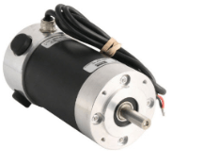DC servomotor

There are various types of dc servo motors which are :

**1. Series motors :**

The series motors have a high starting torque and draws large current. The speed regulation of this kind of motor is poor.

**2. Split series motor :**

They are the motors with split-field rate with some fractional kilowatts. Split series motor has a typical torque-speed curve. This curve denotes high stall torque and a rapid reduction in torque with high speed.

**3. Shunt control motor :**

It has two separate windings:

1.field winding – on the stator.

2.armature winding – on the rotor of the machine.

Both windings are connected to a dc supply source.

**4. Permanent magnet shunt motor :**

It is a fix excitation motor where the field is actually supply by a permanent magnet. Furthermore, the performance is similar to armature controlled fixed field motor.

**2. AC servo motor :**

AC servomotors are AC motors in which incorporate encoders are use with controllers for providing feedback and close-loop control. Hence, these motors can be positioned to high accuracy. Thus they can be controlled exactly as per requirement for the application.

The classification of AC servomotors is done into two types. These are 2 phase and 3 phase AC servo motor. Now most of the AC servomotors are of the two-phase squirrel cage induction motor type. They are used for low power applications. Furthermore the three phase squirrel cage induction motor is now utilized for applications where high power system are in use.

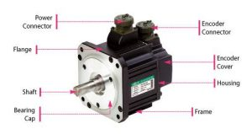AC servomotor

**3. Brushless DC servomotor :**

BLDC motors are also commonly known as electronically commutated motors or synchronous motors powered by DC electricity via inverter or switching power supply. Hence this provides an AC electric current to drive each phase of motor via a closed loop controller. The controller provides pulses of current to the motor windings that control the speed and torque of the motor.

The construction of a brushless motor system is typically similar to a permanent  magnet synchronous motor. Finally the advantages of the brushless motor over brushed motors are high power to weight ratio, high speed, and electronic control. The brushless motors find applications in such places as computer peripherals ( disk drives, printers ), hand-held power tools, and vehicles ranging from model aircrafts to automobiles.

**4. Positional rotation servo motor :**

Positional rotation servo motor is the most important servo motor. Hence it is also the most common type of servo motor. The shaft output  rotates in about 180 degree. Additionally it includes physical stops located in gear mechanism to stop turning outside these limits to guard the rotation sensor. These common servos involve in radio controlled water, ratio controlled cars, aircraft, robots, toys and many other applications.

**5. Continuous rotation servo motor :**

Continuous rotation servo motor relates to the common positional rotation servo motor, but it can go in any direction indefinitely. The control signal, rather than setting the static position of the servo, is understood as speed and direction of rotation. The range of potential commands sources the servo to rotate clockwise or anticlockwise as preferred, at changing on the command signal. Thus this type of motor is used in a radar dish if you are riding, one on a robot or you can use one as a drive motor on a mobile robot.

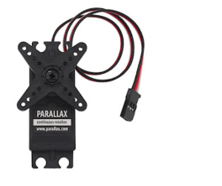continuous rotation  servo motor

**6. Linear servo motor :**

Linear servo motor is also similar to the positional rotation servo motor discussed above, but with extra gears to alter the output from circular to back and forth. Although these servo motors are not likely to be found, but sometimes you can find them at hobby stores where they are used as actuators in higher model airplanes .

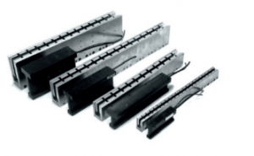linear servomotor

**Principle of working :**

Servo motor works on the PWM ( Pulse Width Modulation ) principle, which means its angle of rotation is controlled by the duration of pulse applied to its control PIN. Basically servo motor is made up of DC motor which is controlled by a variable resistor (potentiometer) and some gears.

**Mechanism of servomotor :**

Basically a servo motor is a closed-loop servomechanism that uses position feedback to control its motion and final position. Moreover the input to its control is a signal ( either analogue or digital ) representing the position commanded for the output shaft .

The motor is incorporates some type of encoder to provide position and speed feedback. In the simplest case, we measure only the position. Then the measured position of the output is compared with the command position, the external input to controller. Now If the output position differs from that of the expected output, an error signal generates. Which then causes the motor to rotate in either direction, as per need to bring the output shaft to the appropriate position. As the position approaches, the error signal reduces to zero. Finally the motor stops.

The very simple servomotors can position only sensing via a potentiometer and bang-bang control of their motor. Further the motor always rotates at full speed. Though this type of servomotor doesn’t have many uses in industrial motion control, however it forms the basis of simple and cheap servo used for radio control models.

Servomotors also find uses in optical rotary encoders to measure the speed of output shaft and a variable-speed drive to control the motor speed. Now this, when combined with a PID control algorithm further allows the servomotor to be in its command position more quickly and more precisely with less overshooting .

**Working of servomotors :**

Servo motors control position and speed very precisely. Now a potentiometer can sense the mechanical position of the shaft. Hence it couples with the motor shaft through gears. The current position of the shaft is converted into electrical signal by potentiometer, and is compared with the command input signal. In modern servo motors, electronic encoders or sensors sense the position of the shaft .

We give command input according to the position of shaft . If the feedback signal differs from the given input, an error signal alerts the user. We amplify this error signal and apply as the input to the motor, hence the motor rotates. And when the shaft reaches to the require position , error signal become zero , and hence the motor stays standstill holding the position.

The command input is in form of electrical pulses . As the actual input to the motor is the difference between feedback signal ( current position ) and required signal, hence speed of the motor is proportional to the difference between the current position and required position . The amount of power require by the motor is proportional to the distance it needs to travel .

**Controlling of servomotors :**

Usually a servomotor turns 90 degree in either direction hence maximum movement can be 180 degree . However a normal servo motor cannot rotate any further to a build in mechanical stop.

We take three wires are out of a servo : positive , ground and control wire.  A servo motor is control by sending a pulse width modulated(PWM) signal through the control wire . A pulse is sent every 20 milliseconds. Width of the pulses determine the position of the shaft .

for example ,

A pulse of 1ms will move the shaft anticlockwise at -90 degree , a pulse of 1.5ms will move the shaft at the neutral position that is 0 degree and a pulse of 2ms will move shaft clockwise at +90 degree.

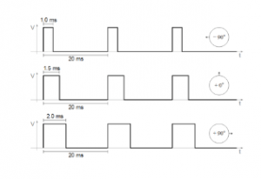variable pulse width control servo motor

When we command a servo motor to move by applying pulse of appropriate width, the shaft moves to and holds the require position of the shaft. However the motor resists to change . Pulses need repetition for the motor to hold the position .

**Applications :**

1. Robotics : At every joint of the robot, we connect a servomotor. Thus giving the robot arm its precise angle.

2. Conveyor belts : servo motors move , stop , and start conveyor belts carrying product along to various stages , for example , in product packaging/ bottling, and labelling  .

3. Camera auto focus : A highly precise servo motor build into the camera corrects a camera lens to sharpen out of focus images.

4. Solar tracking system : Servo motors adjust the angle of solar panels throughout the day and hence each panel continues to face the sun which results in harnessing maximum energy from sunup to sundown .